Information technology

PAT – Design Document - Phase 2

Suhail Essop

Grade 10

**Table of Contents**

**1. User Interface Design 2**

**2. Program Flow 5**

**3. Class Design 5**

**4. Data Storage Design 6**

**5. Storage 7**

1. **User Interface Design**

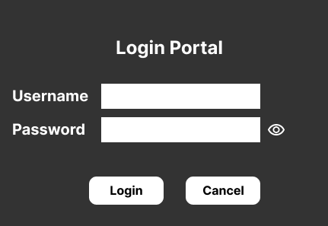

Only registered admin personnel or teachers will be able to access the system through a log in portal.

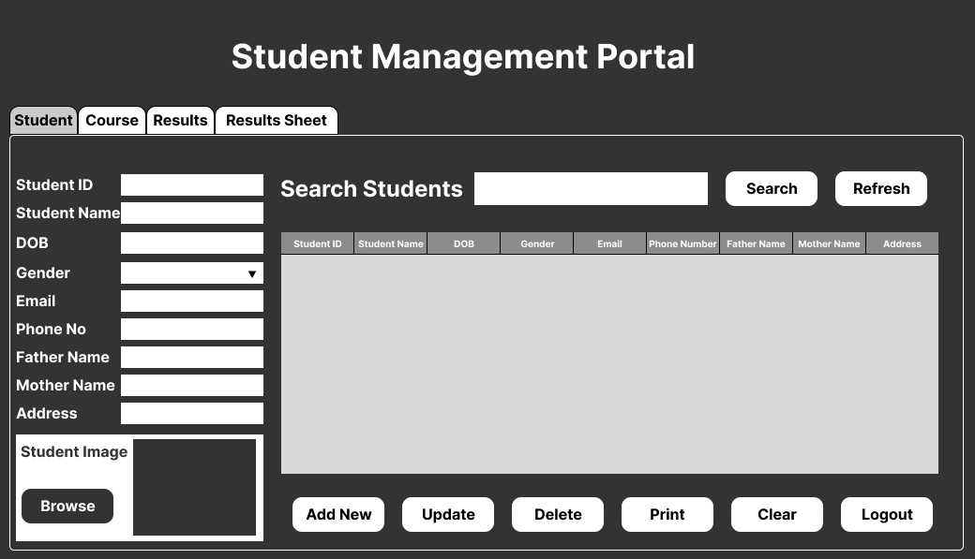

This page allows for editing existing students and adding of new students.

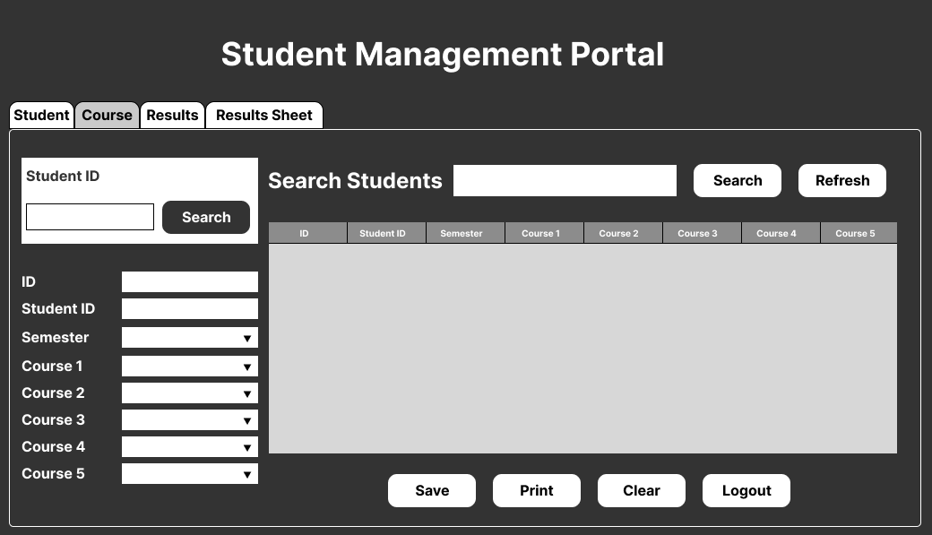

Course page allows for allocation of courses to students for selected semester.

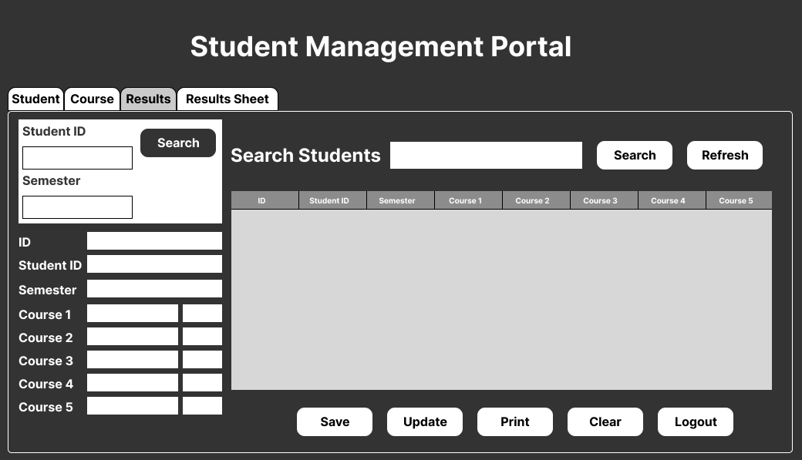

Results page allows to capture marks by student by semester.

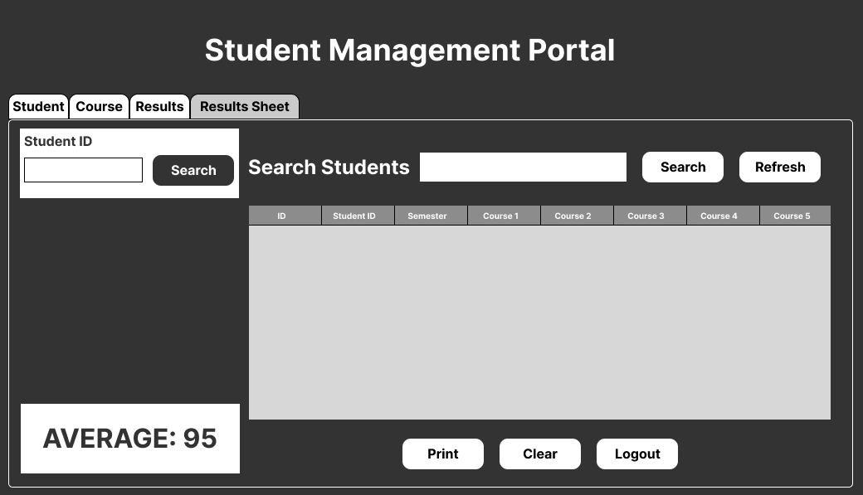

Results Sheet allows you to see all marks for a specific student for all semesters and total average.

1. **Program Flow**
2. **Class Design**

This project makes use of 5 classes:

**MyConnection:**

This class has a getConnection method to establish connection with database

**Student:**

* getLatestId – Gets highest current ID
* insert – Adds new student to database
* isEmailExist – Checks if email already exists
* isPhoneExist – Checks if phone number exists
* isIdExist – Checks if ID exists
* update – Updates existing student
* delete – Deletes existing student

**Subject:**

* getLatestId – Gets highest current ID
* getId – Gets searched student
* countSemester – Checks subjects for specific semester
* isSemesterExist – Checks if semester already exists
* isSubjectExist – Checks if subject has been selected already
* insert – Add subject information
* getSubjectValue – Get all subject details

**Score:**

* getLatestId - Gets highest current ID
* getDetails – Get all current course details
* isIdExist – Check if result ID already exists
* isSidSemesterNoExist – Check if semester ID exists
* getScoreValue – Get current scores
* insert – Insert new results
* update – Update existing results

**MarkSheet:**

* isIdExist – Check if entered ID exists
* getMarksValue – Get requested students marks
* getAverage – Calculate average for selected student

1. **Database Design**

**Admin Table**

**Student Table**

**Course Table**

**Score Table**

1. **Storage**

With the need to make data persist and after researching which database to use I decided on mySQL. After installing mySQL Server Community Edition and then mySQL Workbench to be able to work with the database directly.

The last thing was to install the mySQL driver for Netbeans to be able to interact with the database through the program.